Teen Dating Violence Awareness: Montgomery County Women’s Center
Student’s Name
Institution
Course
Professor’s Name
Date

Contents
Executive Summary 3
Introduction 4
Research Methods 4
Findings and Implications 5
Warning Signs of Teen Dating Violence 6
Risk Factors 7
Preventive Measures to Teen Dating Violence 7
Recommendations and Conclusion 8
References 9

Executive Summary
Teen dating violence is a public issue, not only in Montgomery County but across the United States. Parents and caregivers of teenagers are expected to understand the early signs, the risk factors, and the preventive measures that can be used to help minimize the harmful impacts. This research seeks to provide parents and caregivers such as teachers/coaches with insights on key risk factors, warning signs, and preventive measures that they can use to prevent negative impacts. Drawing findings from secondary resources, this research establishes that teen dating violence is a collective problem that needs to be addressed through a collaborative and multi-level approach.

Teen dating violence awareness: Montgomery County Women’s Center

Introduction
Relationships, among teens, can be complicated and can be defined in various ways. Despite the different ways of defining the relationship, a healthy relationship is very distinct from abusive relationships. All healthy relationships have some common elements including healthy communication, boundaries, mutual respect, and support for each other. As such, this research provides insights for parents and teachers/coaches who guide and cares for teenagers on how they can detect warning signs of dating abuse and the necessary preventive measures that they can consider to prevent further psychosocial effects of teen abuse. This research is guided by the following research questions; what are the warning signs of teen dating violence? What are the preventing measures for teen dating violence? Parents need to equip themselves with this information because it can help the affected teenagers get assistance, including counseling at the right time.

Research Methods
This research is based on data collected from secondary sources. The research adopted a literature review technique, in which the researcher searched for secondary materials online on the topic. The secondary materials used were selected based on their applicability to the topic. For example, only sources that discussed the key aspects of teen dating violence were retrieved and used. The other inclusion criteria involved sources published in the last ten years. The secondary sources used include peer-reviewed article journals, government websites, and news articles published within the last ten years. The thematic analysis approach was used to analyze the literature materials collected in response to the two research questions.

Findings and Implications
Teen dating violence is a major social and public health problem in society today. According to Martsolf et al. (2012), teen dating violence involves physical, psychological, and emotional violence within the dating relationship. Research studies show that teen dating violence affects between 20 to 50% of teenagers while about 80% of teenagers have known someone or a friend who has experienced dating violence (Martsolf et al., 2012). Therefore, as key stakeholders in the caring of teenagers, parents, and teachers/coaches need to understand the concepts of teen dating violence to increase awareness among youths. Some of the things to watch for include the warning signs that can tell the parent or guardian when to take action. Also, parents need to consider preventing measures to ensure that they reduce the potential harm and negative outcomes of teen dating violence.
Several services are offered at Montgomery County Women’s Center which can help young teenagers go through the process of development without problems. These services include emergency shelter, legal services, domestic violence, and sexual assault advocacy, and individual counseling and support groups. Therefore, in regards to counseling and support groups, Montgomery County Women’s Center aims at informing parents and other caretakers involved in the caretaking of teens to help them understand the necessary measures they can take to prevent harmful outcomes associated with teen dating violence such as pregnancy, substance abuse, eating disorder, suicidal intentions, and low life satisfaction (Martsolf et al., 2012). As Ali and Ali (2015) further explain, female teens are the most affected by teen dating violence incidences. According to Ali and Ali (2015), victims of teen dating violence can be affected psychologically.

Warning Signs of Teen Dating Violence
Some of the early signs that can be of concern to the caretakers such as teachers/coaches and parents include extreme jealousy or insecurity from the teens, constant belittling, explosive temper, social isolation, and withdrawal, engaging in lies and making false accusations, physically inflicting pain, and possessiveness (youth.gov). Parents should be able to tell the difference between unhealthy and healthy relationship behaviors. Sometimes, the relationship can be abusive and more difficult than one can think. It is also important to note that no relationship can be the same as another. This means that a relationship that is unhealthy can also be abusive in some way. It is therefore the responsibility of an adult in charge of the teens like teachers and parents to note these differences between unhealthy and healthy relationships to know when to act appropriately. Paying attention to the above-identified signs can be helpful in minimizing the harmful outcomes.
The infographic shown below summarizes the key warning signs that parents can be watchful of to ensure that they prevent harmful consequences.
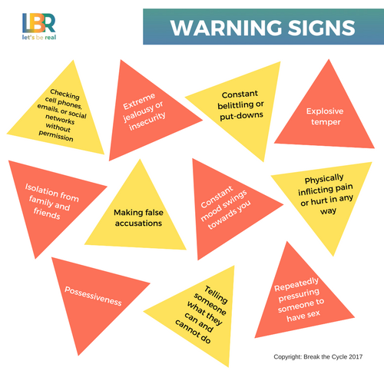
Warning Signs of Teen Dating Violence (Source: breakthecycle.org)

Risk Factors
The findings further showed that the frequency and severity of teen dating violence victimization increases with age. Some of the teen dating violence risk factors include stressful life events including prior victimization, exposure to community or neighborhood violence, dating at an early age, participating in sexual activity before 16 years of age, and peer violence (youth.gov).

Preventive Measures to Teen Dating Violence
As Branco (2019) explains, dealing with teen dating violence requires collaborative and multi-level approaches. This includes the input of everyone involved in the development and welfare of the teenagers ranging from their parents to teachers as well as organizations like Montgomery County Women’s Center. As Branco (2019) further explains, such a multi-level and collaborative approach is important because teen dating violence is not a problem for the parents alone. Everyone in the stakeholder group can contribute. For example, organizations like Montgomery County Women’s Center can help by providing the affected teens with counseling services, but this is not enough. Parents can help by identifying the signs early and taking their children for services or seeking justice for those who have been sexually assaulted. Both parents and teachers also need to talk to the teens and increase awareness on the characteristics of healthy and unhealthy relationships as well as what to do once one faces such behaviors. Branco (2019) further asserts that a collaborative approach involves the input of parents and caregivers, domestic violence, and sexual violence service providers like MCWC, teachers and school-based professionals, and healthcare professionals.

Recommendations and Conclusion
Teen dating violence can negatively affect the individual’s cognitive and psychosocial developments including healthy sexuality, intimacy, and individual’s identity. Despite these potential harmful impacts, teen dating violence can be prevented. Therefore, the preventive measures need to focus on reducing the risk factors and fostering protective factors through empowerment and role modeling from the caretakers and friends. Such strategies can help teens live a healthy life and establish healthy relationships. It is also important to create spaces and avenues where victims of teen dating violence can be assisted such as MCWC. The message that each of these groups should emphasize during this teen dating violence awareness period is that abusive was cannot be tolerated.

References
Ali. Z. A., & Ali, H. N. (2015). Tee Dating Violence. International Journal of Women Empowerment, 1
Branco, P. (2019, January 30). “Preventing and Responding to Teen Dating Violence.” VAW Net (Online). https://vawnet.org/sc/preventing-and-responding-teen-dating-violence
Martsolf, D. S., Colbert, C., & Draucker, C. B. (2012). Adolescent Dating Violence Prevention and Intervention in a Community Setting: Perspectives of Young Adults and Professionals. Qualitative Report, 17, 99.
Youth.gov. Dating Violence Prevention (Online). https://youth.gov/youth-topics/teen-dating-violence

